The North of England Otolaryngology Society Meeting
Friday 22nd November 2024
Chester Zoo
Upton by Chester
CH2 1EU

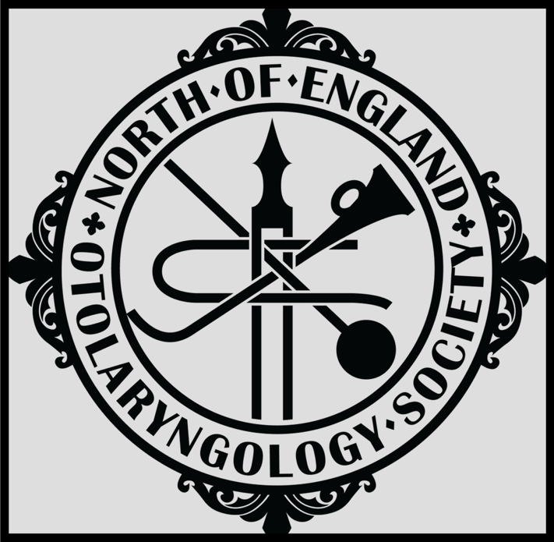

08.30 Registration & Coffee
08.50 Welcome & Presidential address

Session 1
Chair- Ms Bethan Jones
0900 Future of ENT- ENT UK perspective - Miss Helen Cocks

0920 Tribute to Anne Dingle - Mr Jeffrey Lancaster

0930 Roles for SAS doctors beyond clinical practice – Mr Ken Wu

0950 Building and surviving a rhinoplasty service - Professor Tim Woolford

1010 Setting up a smell service - Mr Oke Okechukwu

1030 Coffee Break

Session 2
Chair- Ms Nazia Munir
1050 Trainee short papers
1150 Panel Discussion: Hearing rehabilitation in middle ear disease

Mrs Jaya Nichani, Mr Anand Muddaiah, Mr Sunil Sharma, Mr Ed Flook

1220 Atypical mycobacterial infections in children – Mrs Mira de Kruijf

1245 Lunch/ AGM for members

Session 3
Chair- Mr Fernando Galli
1345 Tribute to Max McCormick – Mr Andrew Swift
1355 Pioneering Hypoglossal nerve stimulation implant in the treatment of OSA- First UK experiance- Mr Yakubu Karagama
1415 Key updates from the latest head & neck cancer guidelines - Prof. Jarrod Homer

1435 Single Port Robotic Surgery in head and neck surgery - Mr Jason Fleming
1500 Coffee break

Session 4
Chair- Mr Glen Watson
1515 Managing failure in surgery - Mr John De Carpentier

1535 Laryngology in Humans & Equine Animals - Mr Andrew Kinshuck & Prof. Debbie Archer
1600 AI and Voice – a North of England collaborative – Miss Katherine Davies
1620 George Seed prize presentation- Mr Tom Hampton

1645 Closing remarks

